

BAHRIA UNIVERSITY (KARACHI CAMPUS)

Software Design & Architecture (SEN-221)

ASSIGNMENT #2 – Spring 2023

Based on: CLO-3

Class: **BSE-4B** Submission Deadline: **07th April 23**

Course Instructor: **ENGR. MAJID KALEEM** Max Marks: **04**

Student Name: **Muhammad Shoaib Akhter Qadri** Enrollment No: **02-131212-009**

1. Designing software applications is a serious job which requires experience and expertise. Suppose you start your professional software engineering career as a developer and you are given the following designs by your senior team member. Your task is to convert the following designs into code (*produce code in C Sharp*). Please write the code in Visual Studio.

(a)

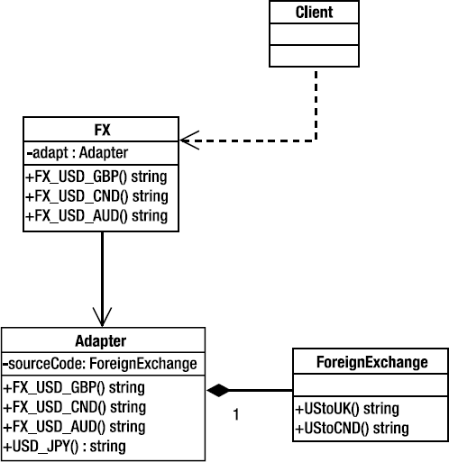

**Source Code:**

**Client Class:**

using System;

using System.Collections.Generic;

using System.Linq;

using System.Text;

using System.Threading.Tasks;

namespace Assignment2

{

class Client

{

private FX fx;

}

}

**FX Class:**

using System;

using System.Collections.Generic;

using System.Linq;

using System.Text;

using System.Threading.Tasks;

namespace Assignment2

{

class FX

{

private Adapter adapt;

public string FX_USD_GBP()

{

return "FX_USD_GBP";

}

public string FX_USD_CND()

{

return "FX_USD_CND";

}

public string FX_USD_AUD()

{

return "FX_USD_AUD";

}

}

}

**Adapter Class:**

using System;

using System.Collections.Generic;

using System.Linq;

using System.Text;

using System.Threading.Tasks;

namespace Assignment2

{

class Adapter

{

private ForeignExchange sourceCode;

public Adapter()

{

sourceCode = new ForeignExchange();

}

public string FX_USD_GBP()

{

return "FX_USD_GBP";

}

public string FX_USD_CND()

{

return "FX_USD_CND";

}

public string FX_USD_AUD()

{

return "FX_USD_AUD";

}

public string USD_JPY()

{

return "USD_JPY";

}

}

}

**ForeignExchange Class:**

using System;

using System.Collections.Generic;

using System.Linq;

using System.Text;

using System.Threading.Tasks;

namespace Assignment2

{

class ForeignExchange

{

public string UStoUK()

{

return "UStoUK";

}

public string UStoCND()

{

return "UStoCND";

}

}

}

(b)

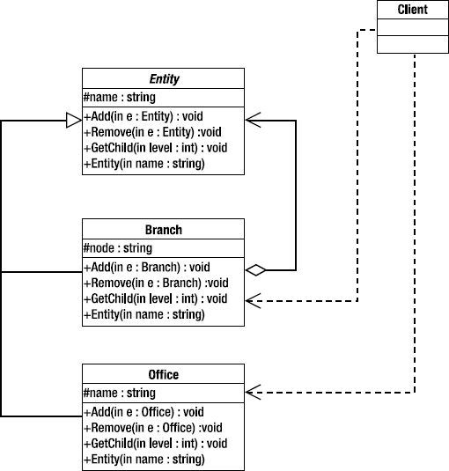

**Source Code:**

**Client Class:**

using System;

using System.Collections.Generic;

using System.Linq;

using System.Text;

using System.Threading.Tasks;

namespace Assignment2

{

class Client

{

private Branch branch;

private Office office;

}

}

**Entity Class:**

using System;

using System.Collections.Generic;

using System.Linq;

using System.Text;

using System.Threading.Tasks;

namespace Assignment2

{

class Entity

{

protected string name;

public Entity(string name)

{

this.name = name;

}

public void Add(Entity e) { }

public void Remove(Entity e) { }

public void GetChild(int level) { }

}

}

**Branch Class:**

using System;

using System.Collections.Generic;

using System.Linq;

using System.Text;

using System.Threading.Tasks;

namespace Assignment2

{

class Branch:Entity

{

protected string node;

Entity entity;

public Branch(Entity entity,string name) : base(name)

{

this.entity = entity;

}

public void Add(Branch e){}

public void Remove(Branch e) { }

public void GetChild(int level) { }

}

}

**Office Class:**

using System;

using System.Collections.Generic;

using System.Linq;

using System.Text;

using System.Threading.Tasks;

namespace Assignment2

{

class Office:Entity

{

protected string name;

public Office(string name):base(name)

{

this.name = name;

}

public void Add(Office e) { }

public void Remove(Office e) { }

public void GetChild(int level) { }

}

}